Welcome to Sleep and TMJ Therapy!
We would like to help you make the most of your visit. Included is a list of local attractions, eateries, lodging, and travel options for your convenience. Please feel free to contact us with any questions or concerns.
We look forward to meeting and working with you!

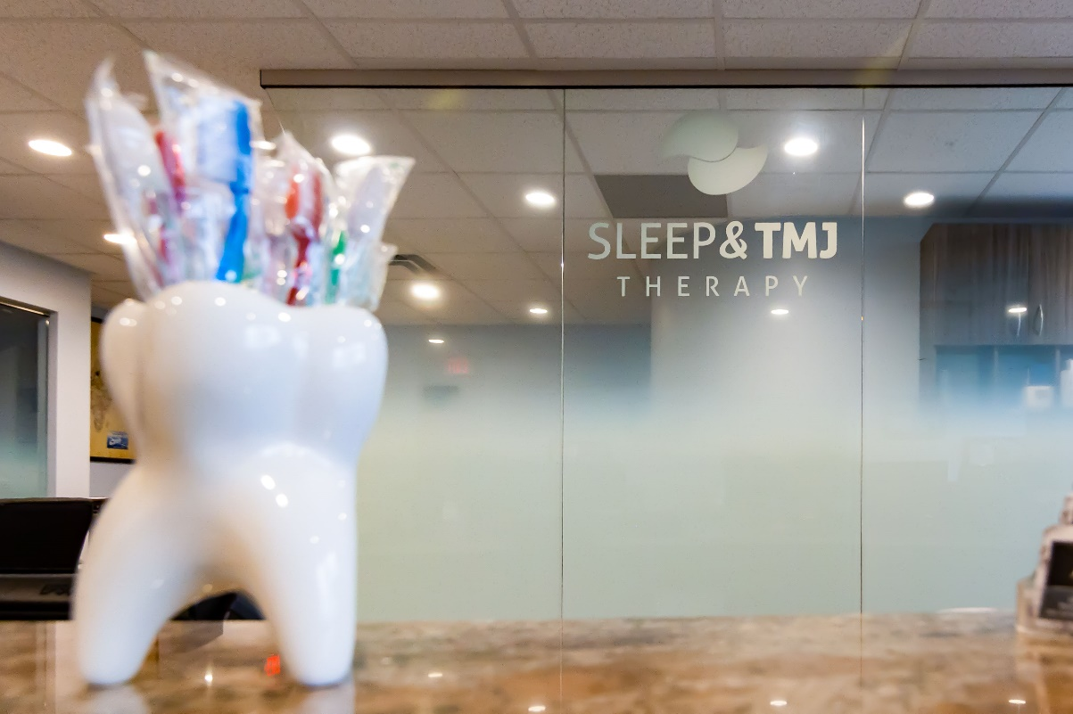

Office Information:
Address: 2841 Hartland Road Suite 301 Falls Church, VA 22043
Website: www.sleepandtmjtherapy.com
Office number: 1(703) 821-1103
Email: Office@sleepandTMJtherapy.com
Office Hours: M-F 7:00am-4:00pm

TRANSPORTATION

Local Airports:

Dulles International Airport (IAD)
1 Saarinen Cir. Dulles, VA
(20.1 miles from our office)

Ronald Reagan National Airport (DCA)
1 Aviation Cir. Washington, DC
(19.3 miles from our office)
Baltimore Washington International Airport (BWI)
7050 Friendship Rd. Baltimore, MD
(50.4 miles from our office)

Train Stations:

Union Station
50 Massachusetts Ave NE.
Washington, DC

Amtrak – Alexandria VA
110 Callahan Dr.
Alexandria, VA

Local Transportation:
Dunn Loring Metro Station
2700 Gallows Rd. Vienna, Va.
(0.3 miles from our office)
Vienna/FFX-GMU Metro Station
9550 Saintsbury Dr. Fairfax, Va.
(3 miles from our office)
Enterprise Rent-a-Car
3055 Nutley St. Fairfax
1 (703) 280-4646
Fairfax Taxi Service
1 (703) 859-8294

Fairfax Red Top Cab
(703) 333-3333
Washington Metro/Bus Service
Trip planner: https://www.wmata.com/

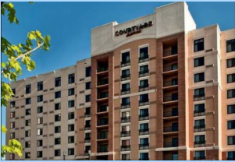
HOTELS
Courtyard Dunn Loring Fairfax (Pet Friendly)
2722 Gallows Rd, Vienna, VA 22180
1(703) 573-9555
(.7 miles from our office)

Archer Hotel Falls Church (Pet Friendly)
8296 Glass Alley Fairfax, Virginia, USA, 22031
1(571) 327-2277
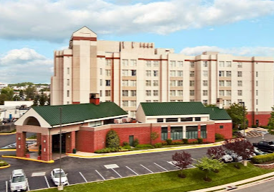
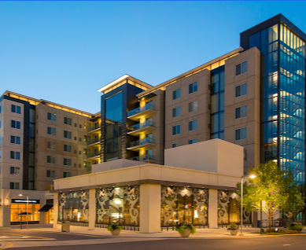
(.8 miles from our office)
Homewood Suites by Hilton (Pet Friendly)
8130 Porter Road, Falls Church, Virginia, 22042
1(703) 560-6644
(.5 miles from our office)

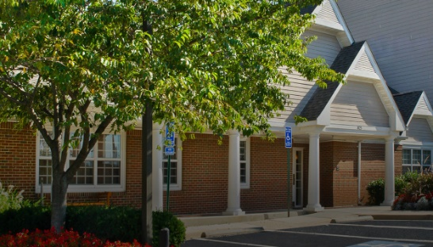
Residence Inn Fairfax Merrifield
(Pet Friendly)
8125 Gatehouse Rd
Falls Church, VA 22042
1(703) 573-5200
(.5 miles from our office)

Extended Stay America (Pet Friendly)
8281 Willow Oaks Corporate Dr
Fairfax, VA 22031
1(703) 204-0088
(1.3 miles from our office)

Budget Inn Falls Church
7155 Lee Highway
Falls Church, VA 22046
1(703) 533-8600
(2.5 miles from our office)

Hilton Garden Inn (Pet Friendly)
706 West Broad Street
Falls Church, Virginia, 22046
1(703) 237-8700
(2.9 miles from our office)

TownePlace Suites
205 Hillwood Ave
Falls Church, VA 22046
1(703)237-6172
(3 miles from our office)

Comfort Inn
6111 Arlington Blvd
Falls Church, VA 22044
1(703) 534-9100
(5 miles from our office)

ENTERTAINMENT

Tyson’s Corner Shopping Center (Shopping/Dining/Movies)
1961 Chain Bridge Rd. McLean, VA
Tyson’s II Galleria
2001 International Drive McLean, VA
Meadowlark Botanical Gardens
9750 Meadowlark Gardens Ct Vienna, VA
Washington National Zoo
Connecticut Ave NW, Washington DC
Washington Monument and Mall
2 15th St. NW. Washington, DC
International Spy Museum
700 L'Enfant Plaza SW, Washington, DC
Clemyjontri Park
6317 Georgetown Pike Mclean, VA

Mosaic District (Shopping/Movies/Dining)
2905 District Ave. Fairfax, VA
National Aquarium
Baltimore, MD
Bowl America Website
9699 Fairfax Blvd, Fairfax, VA
Top Golf
6625 S Van Dorn St Alexandria, VA
iFLY Loudoun (Indoor Sky Diving)
20315 Commonwealth Center Drive Ashburn, VA
AMC Tyson's Corner (Movie Theater)
7850 Tysons Corner Center McLean, VA
National Portrait Gallery
8th and F St. NW Washington, DC

Getting Your MRI at Tyson’s Imaging Center
